Akaal Singh’s - Paneer Matar Recipe
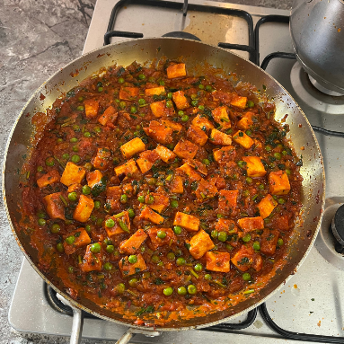
Ingredients:
A block of paneer (200g)
1 onion
1 tin of tomatoes
1 or 2 green chillies
50 pence piece size of garlic
1 tsp of turmeric powder*
1tsp salt*
Half a tsp of masala *
*For the last three, they’re rough estimates, I always eyeball it!
Also, we make our own masala, so if you buy it premade, then get a good quality one, because that can make or break the dish.

Instructions:
- Fry some finely chopped onions, alongside a piece of ginger (50p size) and add a green chilly (or more if you want a spicier dish).
- Cut the paneer into small chunks and add to the pan once the onions start to brown. Mix it in.
- Then add ¾ of the tomatoes into the pan, keep it separated from paneer and onions by pushing them to one side of the pan.
- You want to fry the tomatoes and let them concentrate a bit. Add a bit of water to the tomatoes if they become too dry. Repeat this a few times until the tomatoes become almost like a creamy texture.
- Don’t burn your paneer or onions. Keep moving them around, just don’t mix it in with the tomatoes yet.
- Once you feel like the tomatoes are at that stage, you can then mix it all together.
- Then add some salt, a little bit of masala (too much can ruin the dish), and add some haldi (turmeric powder) – I don’t know measurements, I just eyeball it, so whilst you’re cooking, taste it to see if it needs more of a seasoning.
- Add some water and mix it all together. Repeat this step until it’s looking creamy again and there is oil oozing out of the tomatoes.
- Penultimately, add some small peas (I use frozen peas), and mix it in.
- Finally, add some coriander on top, mix it in and feel free to add a bit more for aesthetic purposes.
- Serve with Roti, Naan bread or rice (or whatever floats your boat).

Credit: Mum’s Recipe

